Variant Management Sample
Validation of Generic Structure



Aras Corporation
© 2002 Aras Corporation. All rights reserved

Aras Corporation
300 Brickstone Square
Suite 700
Andover, MA 01810

Phone: 978-794-7643
Fax: 978-794-9826

E-mail: info@aras-corp.com
Website: http://www.aras-corp.com

Notice of Rights
All rights reserved. Aras Corporation (Aras) owns this document. No part of this document may be reproduced or transmitted in any form by any means, electronic, mechanical, photocopying, recording, or otherwise, without the prior written permission of Innovator and other Aras product names and logos are trademarks of Aras Corporation.

Notice of Liability
The information contained in this document is distributed on an “As Is” basis, without warranty. While every precaution has been taken in the preparation of this document, Aras shall have no liability to any person or entity with respect to any loss or damage caused or alleged to be caused directly or indirectly by the information contained in this document or by the software or hardware products described in it.

NAME | Description of update | Date Updated
Olena Zaporozhets | Initial Creation from VM_Sample_Smoke_Variability_Item.doc | 02/12/2021

Table of Contents

1 Send Us Your Comments 4
2 Overview 5
3 Prerequisites 6
3.1 Server Machine Setup 6
3.2 Client Machine Setup 6
3.3 Make sure notifications about every scripts error enabled in your browser 6
4 Functional Tests 7
4.1 Test Setup 7
4.2 Validate a Generic Structure 7
4.3 Validate Selection 10
4.4 Get Reasons 12

Send Us Your Comments
Aras Corporation welcomes your comments and suggestions on the quality and usefulness of this document. Your input is an important part of the information used for future revisions.
- Did you find any errors?
- Is the information clearly presented?
- Do you need more information? If so, where and what level of detail?
- Are the examples correct? Do you need more examples?
- What features did you like most?

If you find any errors or have any other suggestions for improvement, indicate the document title, and the chapter, section, and page number (if available).

You can send comments to us in the following ways:
- Email:
Support@aras.com
Subject: Aras Innovator Documentation
Or,
- Postal service:
Aras Corporation
300 Brickstone Square
Suite 700
Andover, MA 01810
Attention: Aras Innovator Documentation
Or,
- FAX:
978-794-9826
Attn: Aras Innovator Documentation

If you would like a reply, provide your name, email address, address, and telephone number.

If you have usage issues with the software, visit http://www.aras.com/support/

Overview
This Smoke Test document will go through and validate that the basic functionality of Variant Management Application.

Prerequisites
There are a few prerequisites that need to be done before the test plan can be executed.

Server Machine Setup
- Innovator needs to be set up (refer to the Innovator install guide)
- Vaults need to be set up and functional (refer to the Innovator install guide)
- Your database needs to be a FRESH database with all the correct patches applied to it
- You should have the previous version of Innovator installed on the system as well. (This helps catch installer errors.)

Client Machine Setup
- Clean up cache
  - Delete Browser temporary files
  - Delete assembly files
- If Browser Firefox delete Innovator XPI extension from list of Firefox Add-ons

Make sure notifications about every scripts error enabled in your browser

Functional Tests

Test Setup
Test # | VM-1-001
Purpose: | To prepare instance and data for further testing.
- Download VM build.
- Launch Aras Update.
  - Go to Local tab.
  - Click on “Add package reference”.
  - Select Folder with VM build – Click OK.
    - Confirm that VM Sample is displayed in the list of packages.
- Click on Install – Next – Next.
  - Click on Browse for Install Path field.
  - Select the path of the necessary instance to the Innovator folder.
- Expand Aras Innovator Database Updates.
  - Fill in Server URL, Database.
  - Username: admin.
  - Password: innovator.
- Click on Install.
  - Confirm that VM sample successfully installed.
- Use the nash.aspx and apply AML
  - Login as admin / innovator.
  - Apply VM_Structure.xml.

Validate a Generic Structure
Test # | S-1-009
Purpose: | to Validate a Generic Structure and Verify Which Options are not available
Test Setup | Pass setup from 4.1
- Log into Innovator as admin

- Go to Variant Management section in Navigation panel -> Variability Items -> Open TestVI1 -> Edit
- Create rules
  - Go to Text Rules Editor Tab
  - Click Create New icon and type:
IF TestFeature1 = TestOption1 THEN TestFeature3 = TestOption5”
  - Save TestVI1
  - Click Create New icon and type:
IF TestFeature3 = TestOption6 THEN NOT (TestFeature4 = TestOption8)
  - Save TestVI1
  - Click Create New icon and type:
NOT TestFeature2 = TestOption4
  - Save TestVI1

- Test a Validation of Variability Structure and all Options
  - Go to Validation Tab on sidebar
    - Confirm that:
Validation is false
1 option(s) are not available for selection
TestFeature2=TestOption4

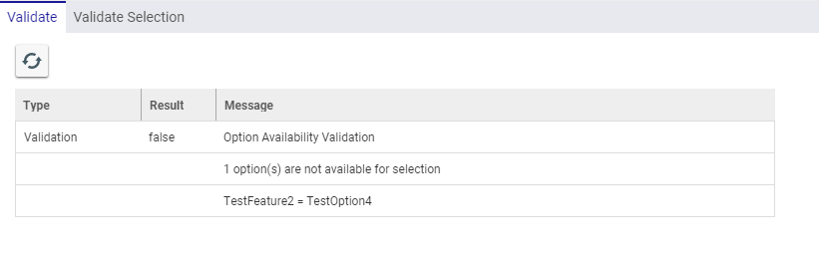
  - Go to Text Rule Editor Tab
  - Create New Rule:
TestFeature3 = TestOption6
  - Save Item
  - Go to Validation Tab on sidebar
    - Confirm that
Validation is false
4 option(s) are not available for selection
TestFeature1=Option1, TestFeature2=Option4, TestFeature3=Option5, TestFeature4=Option8

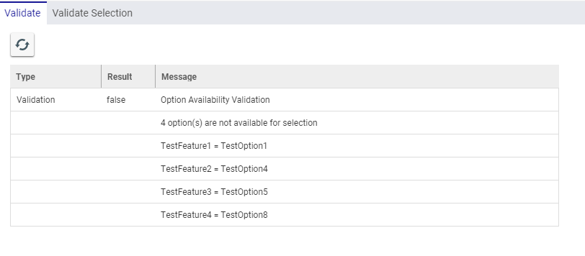
  - Go to Text Rule Editor Tab
  - Create New Rule:
TestFeature3 = TestOption5
  - Save Item
  - Go to Validation Tab on sidebar
    - Confirm that
Validation is false
Message “There are no valid option combinations for this Variability Item.”

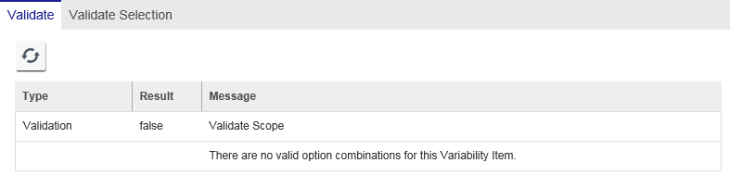
  - Go to Text Rule Editor Tab
  - Delete Rules:
NOT TestFeature2 = TestOption4
TestFeature3 = TestOption6
TestFeature3 = TestOption5
  - Save Item
  - Go to Validation Tab on sidebar
    - Confirm that Validation Result is true
  - Close Variability Item TestVI1

- Test Validation in according with Rules created on a leaf Variability Item:
  - Select TestVI2 on main grid –> RMB -> Open –> Click Edit
  - Go to Text Rule Editor Tab
  - Create New Rule:
TestFeature3 = TestOption5
  - Save Item
  - Go to Validation Tab on sidebar
    - Confirm that
Validation is false
1 option(s) are not available for selection
TestFeature3 = TestOption6

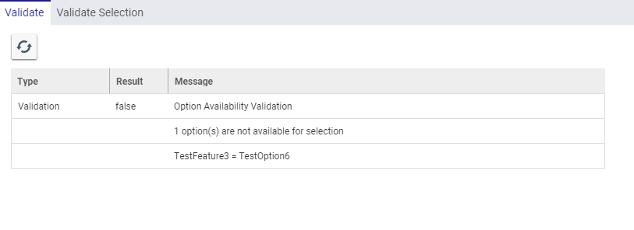
  - Click Done -> close TestVI2

  - Open TestVI1
  - Go to Validation Tab on sidebar -> Validation tab
    - Confirm that
Validation is false
1 option(s) are not available for selection
TestFeature3 = TestOption6
  - Close TestVI1

Validate Selection
Test # | S-1-010
Purpose: | to Validate Selected Options in accordance with Rules
Test Setup | Pass Test cases from 4.2
- Log into Innovator as admin

- Go to Variant Management section in Navigation panel -> Variability Items -> Open TestVI1 -> Edit
- Test a Validation a Variability Structure and all Options
  - Go to Validation Tab on sidebar -> Validate Selection tab
    - Confirm that selection Tree is displayed
    - Confirm that Validate Selection button is enabled
  - Click Validate Selection
    - Confirm that Validation Result is displayed in right splitter pane and it is Successful
  - Select
TestOption1 for TestFeature1,
TestOption7 for TestFeature4
  - Click Validate Selection
    - Confirm that Validation Result is Successful
  - Uncheck selected options
  - Select in Selection column:
TestOption1 for TestFeature1
TestOption3 for TestFeature2
TestOption5 for TestFeature3
TestOption7 for TestFeature4
  - Click Validate Selection
    - Confirm that Validation Result is Successful
  - Select TestOption6 for TestFeature3
    - Confirm that TestOption6 is red and all options besides TestOption5 became red
  - Click Validate Selection
    - Confirm that
Validation Result is Failed
These options cannot be selected with the current selection.
TestFeature1=TestOption1
TestFeature2=TestOption3
TestFeature4=TestOption7
TestFeature3=TestOption6

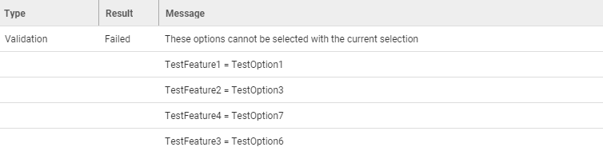

  - Close TestVI1

- Test Validation Selection with new Options:
  - Go to Variant Management section in Navigation panel -> Dictionary -> Features -> Open TestFeature2 -> Edit ->go to Options tab -> Click New Option
Code: 07
Name: New
  - Click Done -> Close item

  - Open TestVI1 -> Edit
  - Go to Validation Tab on sidebar -> Validate Selection tab
    - Confirm that Option “New” don’t red and is available
  - Select New for TestFeature2
  - Click Validate Selection
    - Confirm that Validation Result is Successful

- Test Validation Selection with new Rules:
  - Go to Table Rule Editor Tab
  - Choose TestFeature2 as Principal Group
  - Choose TestFeature4 as Constrained Group
  - Click RMB at the intersection New and TestOption7
  - Choose Include
    - Confirm that “IF TestFeature2 = New THEN TestFeature4 = TestOption7” shows in Rule Expression
  - Save Item
  - Go to Validation Tab on sidebar -> Validate Selection tab
  - Select
New for TestFeature2,
TestOption8 for TestFeature4
    - Confirm That after selection New for TestFeature2 Option “TestOption8” is red
  - Click Validate Selection
    - Confirm that
Validation Result is Failed
These options cannot be selected with the current selection.
TestFeature2=New
TestFeature4=TestOption8

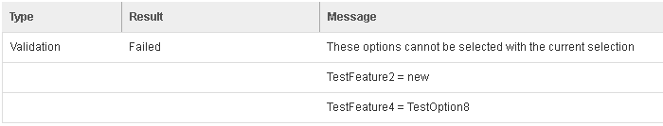

  - Go to Text Rule Editor Tab
  - Create New Rule
NOT (TestFeature3 = TestOption5)
  - Save Item
  - Go to Validation Tab on sidebar -> Validate Selection tab
    - Confirm that all options are red
  - Go to Text Rule Editor Tab
  - Delete the Rule
NOT (TestFeature3 = TestOption5)
  - Save Item
  - Go to Validation Tab on sidebar -> Validate Selection tab
    - Confirm that only TestOption6 is red
  - Click Done -> close TestVI1

Get Reasons
Test # | S-1-011
Purpose: | To view conflicts and get reasons why some Options can’t have selected
Test Setup | Pass Test cases from 4.2-4.3
- Log into Innovator as admin

- Go to Variant Management section in Navigation panel -> Variability Items -> Open TestVI1
- View Conflicts for Variability Structure:
  - Go to Validation Tab on sidebar -> Validate Selection tab
    - Confirm that Get Reasons button is disabled
  - Choose the following Options:
TestOption1 for TestFeature1
TestOption3 for TestFeature2
TestOption5 for TestFeature3
    - Confirm that TestOption6 is red
TestOption7 for TestFeature4
    - Confirm that Get Reasons button is still disabled
  - Uncheck all Options
  - Choose the following Options again:
TestOption1 for TestFeature1
TestOption3 for TestFeature2
TestOption6 for TestFeature3
    - Confirm that TestOption6 is red
    - Confirm that Get Reasons button is enabled
TestOption7 for TestFeature4
    - Confirm that TestOption7 is red
    - Confirm that Get Reasons button is enabled
  - Click Get Reasons button
    - Confirm that Conflicts were opened in a new Tab
    - Confirm that there is icon near name of Conflicts tab
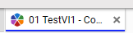
    - Confirm that two Conflicts are displayed, and the first page of Conflicts table looks as the picture below:
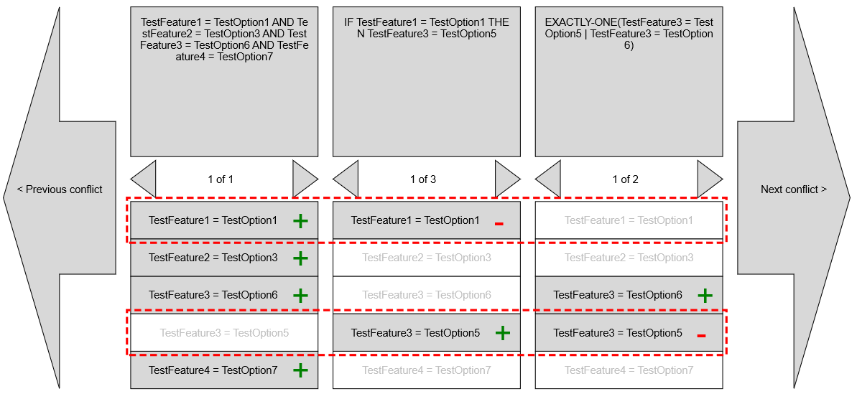

  - Adjust the Scale of Conflicts
    - Confirm that scale increase and decrease successfully
  - Click Next Conflict
    - Confirm that the second Conflict displayed
  - Click Previous Conflict
    - Confirm that the First Conflict displayed
  - Click on Next Variant  in secont Collumn
    - Confirm that TestFeature1 = TestOption1 becomes marked and that this row don’t highlighted in red anymore
    - Confirm that with any selected Variants in columns always at least one row is highlighted in red
  - Close Conflicts Tab

- Test Conflicts in accordance with new Rules
  - Click Edit for TestVI1
  - Go to Table Rule Editor Tab
  - Choose TestFeature3 as Principal Group
  - Choose TestFeature4 as Constrained Group
  - Click RMB at the intersection TestOption5 and TestOption7
  - Choose Include
  - Confirm that new rule is
IF TestFeature3 = TestOption5 THEN TestFeature4 = TestOption7
  - Save Item
  - Go to Validation Tab on sidebar -> Validate Selection tab
    - Confirm that Get Reasons button is disabled
  - Choose the following Options:
TestOption5 for TestFeature3
TestOption8 for TestFeature4
    - Confirm that TestOption8 is red and not available
    - Confirm that Get Reasons button becomes enabled
  - Click Get Reasons button
    - Confirm that Conflicts were opened in a new tab
    - Confirm that the only one Conflict is displayed
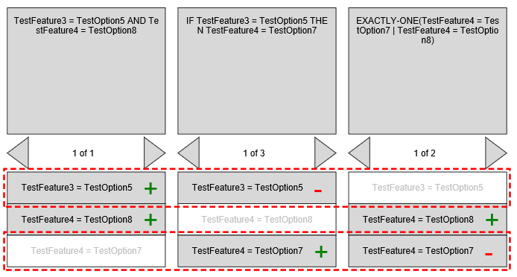
    - Confirm that Navigation buttons are not displayed
    - Confirm that in second Column displayed Rule “IF TestFeature3 = TestOption5 THEN TestFeature4 = TestOption7”
  - Close Conflicts tab
  - Go to Text Rule Editor Tab
  - Delete rule:
IF TestFeature3 = TestOption5 THEN TestFeature4 = TestOption7
  - Create new rule:
NOT (TestFeature3 = TestOption5)
  - Save Item
  - Go to Validation Tab on sidebar -> Validate Selection tab
    - Confirm that Get Reasons button is enabled
    - Confirm that all Options are red
  - Click Get Reasons
    - Confirm that only one Conflict Displayed and there are no Navigation buttons
    - Confirm that in one Column has Rule “Not(TestFeature3=TestOption5)” and another Column has Rule “TestFeature3=TestOption5”

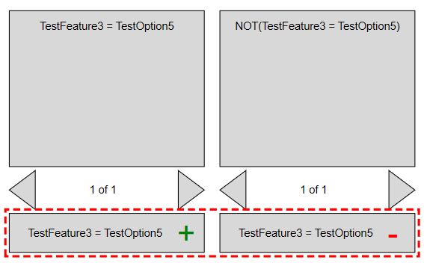

  - Close Conflicts Tab
  - Go to Text Rule Editor Tab
  - Delete the Rule “NOT (TestFeature3 = TestOption5)”
  - Click Done -> close TestVI1
Test CleanUp | Login as admin/innovator  Apply Clean_Up.xml

